DEVELOPMENT

LIFE CYCLE

**Version :** 1.0

**Updated:** 06/01/2022

**Prepared by:** Cuong Tran

Table of Contents

1 Development Life Cycle Diagram 3

2 Development Life Cycle Detail 4

2.1 Requirements 4

2.2 Analysis & Planning 4

2.2.1 Analysis 4

2.2.2 Planning 4

2.3 Development 4

2.3.1 Set up 4

2.3.2 Source version control 4

2.3.3 Implementation 4

2.4 Testing 5

2.4.1 UAT environment 5

2.4.2 Production environment 5

2.5 Release 5

2.5.1 UAT environment 5

2.5.2 Production environment 5

2.6 Deployment 5

2.6.1 UAT environment 5

2.6.2 Production environment 5

# Development Life Cycle Diagram

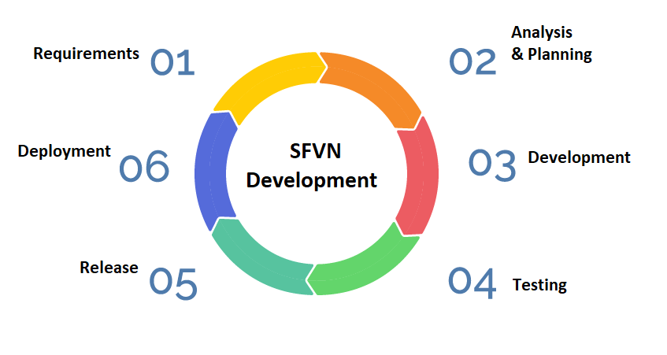

# Development Life Cycle Detail

## Requirements

* Business Analysis (BA) team discusses with user and collect all requirements.
* Design Business Requirement Document (BRD) for all requirements.

## Analysis & Planning

### Analysis

* Development team reads & analysis requirements.
* Pick up the techniques which apply for the project.
* In case development team get concern for requirement, explain it to BA and re-discuss with user to recorrect the requirement then finalize the BRD.

### Planning

* List out all functions and estimate timeline; then send it to Project Manager (PM).
* PM and User review and confirm it before developing.

## Development

### Set up

* Set up development tools for project.
* Set up Version Control System – VCS such as Github, Gitlab.
* Design Database.

### Source version control

* Get code from “Develop” branch.

### Implementation

* Init and define structure for Back-end and Front-end.
* Development team members implement the function as planning. When each function is finished, developer commit source code on “Develop” branch.
* Fix issue on UAT & Production environment.

## Testing

### UAT environment

* Business team and user test the function on UAT.
* If testing is false, business team raises issue and assign to development team for fixing issue.

### Production environment

* User starts rehearsal test on Production environment.
* User raises issue and assign to development team for fixing issue.

## Release

### UAT environment

* When a function is finished development for fixing bugs or enhancement request. Source code is merge to “release” branch for deployment on UAT environment.

### Production environment

* When business team and user finish the testing on UAT environment. Source code is merge on “master” branch for deployment on Production environment.

## Deployment

### UAT environment

* Development team sends a deployment request for Infra Team.
* Infra Team builds and deploys on “release” branch for UAT environment.

### Production environment

* When business team & user confirmed that finish the testing and clear all issue on UAT environment. Development team sends a deployment request for Infra Team.
* Infra Team builds and deploys on “master” branch for Production environment.